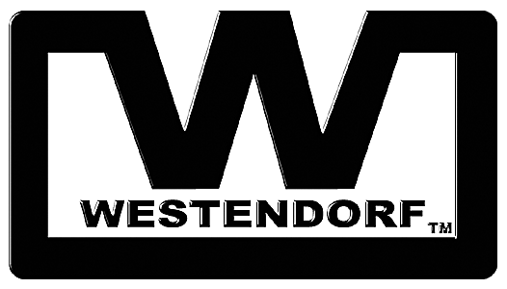
Contact: Matt Westendorf FOR IMMEDIATE RELEASE
Tel: 712-423-2762
Email: matt@westendorfmfg.com

WESTENDORF – INNOVATING THE LOADER

Freedom Mount™ Loaders Elevate Standards to a New Height

ONAWA, Iowa – Westendorf has been a leading loader manufacturer for decades, and it's taken all that experience and rolled it into the new Freedom Mount Series of Loaders. The unit features a low-profile, curved box I-beam arm, contractor-grade bucket with remote couplers to change attachments with the push of a button, simple bracket design, protected hydraulic lines and Gold-Line cylinders, extended lift height, and clean dump and water holding roll-back angles. And it offers a tool-free, stand-free dismount design with automatic lock-on feature. Call 1-866-MYLOADER (1-866-562-3374) or visit www.loaders.com/freedom for more information.

About Westendorf Manufacturing Co., Inc.
Since 1934 Westendorf Manufacturing, a pioneer in the industry, has designed and manufactured “Power-Mount™” loaders, the “Snap Attach™” system for quick-change attachments, wagon gears and versatile accessories, such as grab forks, buckets, blades, v-plows, land scrapers, fork lifts and booms. For more information, visit the web site at www.loaders.com.

# # #

If you’d like more information about this topic, or to schedule an interview with Matt Westendorf, please contact Julie Ellingson at 712-423-2762.

